Level3

Samkary parmaga

For Learn basic python

Lesson1

List

Introduction:

In the previous levels you learned some commands and operations and you also learned some functions for texts. Today you will learn how to save data in a list in order to save space and run any program that you want to save large data.

**Lists**: are used to store multiple items in a single variable. Lists are created using square brackets ([]).

**Benefits of the list:**

1. Organize data
2. You can store a large amount of data.
3. Quick access to any item in the list
4. You can store different data types, but it's better to keep the same type for organization
5. You can also reach all the list items by loops.
6. Easy to add and remove items

**How to create a list?**

To create a list, you write the list name, add =, and then create a square bracket like this:

frinds = ['yousef','abdo','anna','hesham','lujina']

If you want to print a list, easy just write print then write list name like this:

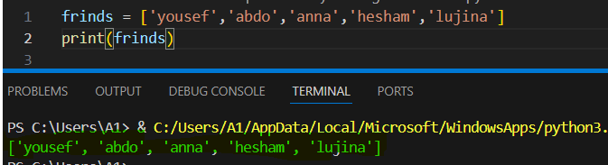

## List Methods:

1. **Append() :** Adds an element at the end of the list.

Like this:

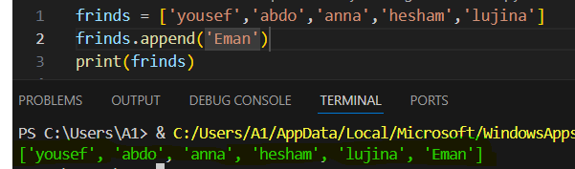

1. **Insert():** Adds an element at the specified position. Syntax: name_list.insert(index,new element,…)

Like this:

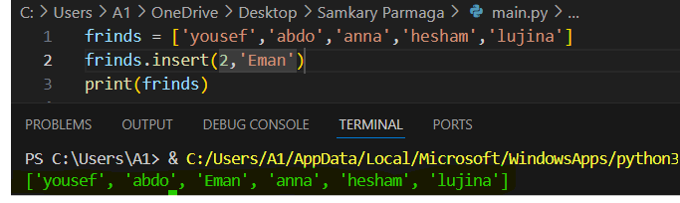

1. Pop(): Removes the element at the specified position. Syntax:

name_list.pop(index)

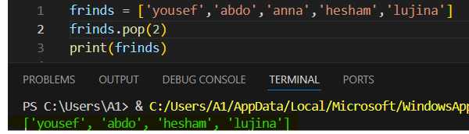

Note: If no index is written, the last item in the list will be deleted.

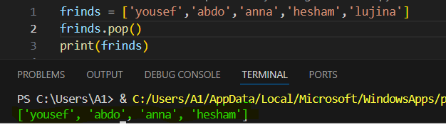

1. **Remove():** Removes the item with the specified value.

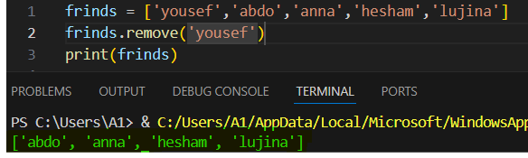

1. Clear(): Removes all the elements from the list.

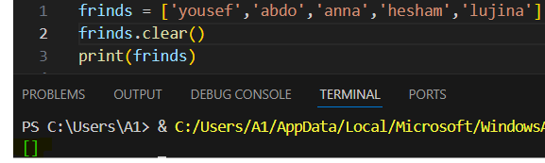

1. Sort(): sort the list from Minimum value to maximum value

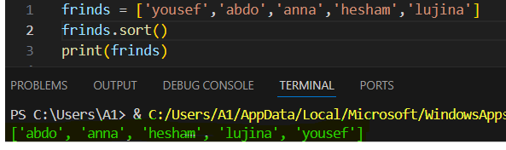

1. Reverse(): Reverses the order of the list from maximum value to minimum

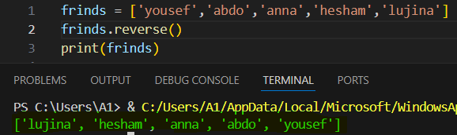

1. Index(): method returns the position at the first occurrence of the specified value. Syntax: name_list.index(element,start,end)

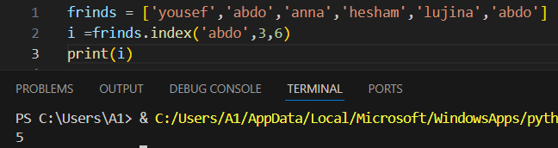

Note: If you do not write the beginning and end of the index, it will search for the name of the element in the list and return the index.

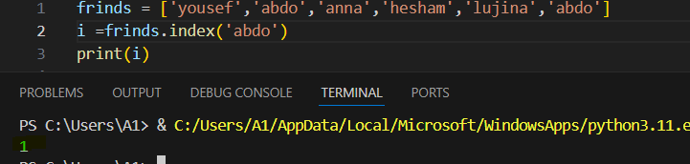

1. Extend(): Add the elements of a list (or any iterable), to the end of the current list

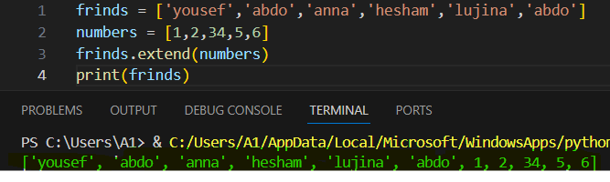

**Example:**

Build a simple program that takes your friend's name and saves the names in a list.

**Solution:**

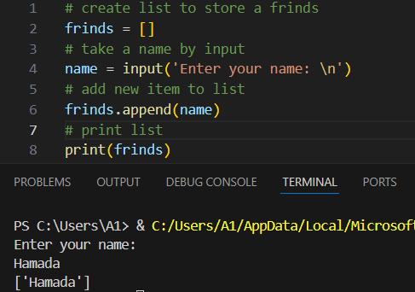

Finish the lesson!!!

Lesson2

# Operators & Math functions in Python

**Introduction:**

In the previous levels, you may have learned some operations to perform a special operation or a special task, but today you will complete the series of operations, Part 3, and complete the series of learning functions in Python. Today it will be about numeric functions.

1. **Operators:** are special symbols used to perform specific operations on one or more operands.

* **Identity**: are used to compare the objects, not if they are equal, but if they are actually the same object, with the same memory location.

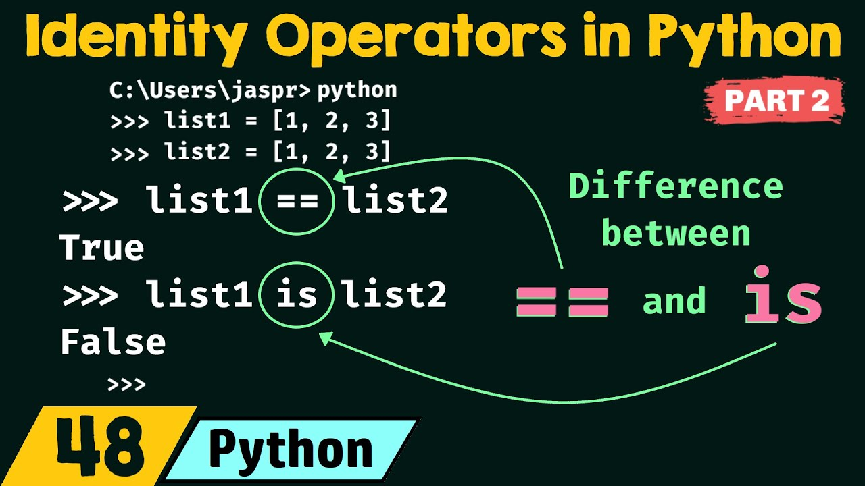

What is the difference between == & is?

Imagine with me that you have two bags, both bags have the same contents in terms of pen, notebook, and book. If I asked you if the two bags have the same contents, you would say yes, that’s what it’s called”==”. But if I asked you if the two bags have the same in everything, the answer would be no, because the shape of the bag is different from the other, even though the contents inside it are the same, and this is called “is”.

Identity consists of two things: is,is not

|  |  |
| --- | --- |
| operator | Definition |
| is | Returns True if both variables are the same object |
| Is not | Returns True if both variables are not the same object |

Example:

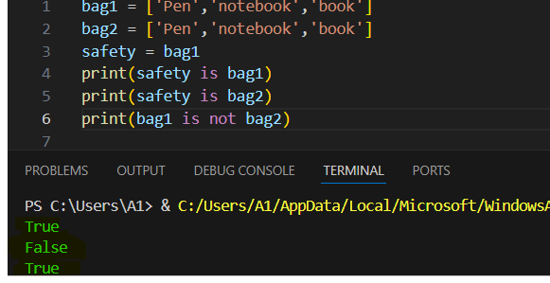

* Membership: operators are used to test if a sequence is presented in an object.

Membership contains two things: in, in not.

|  |  |
| --- | --- |
| operator | Definition |
| in | Returns True if a sequence with the specified value is present in the object |
| Not in | Returns True if a sequence with the specified value is not present in the object |

Example:

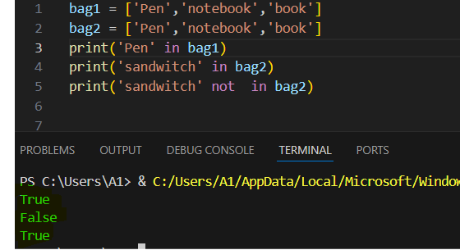

1. Math functions in Python: They are functions that perform functions to calculate numbers faster and more understandably.

* Min():function can be used to find the lowest value in an iterable.

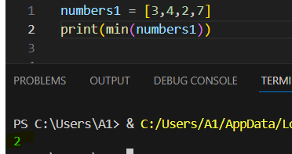

* Max(): function can be used to find the highest value in an iterable.

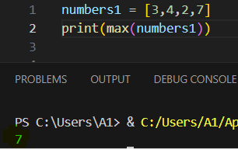

* Abs(): function returns the absolute (positive) value of the specified number.

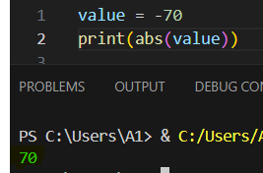

* Pow(x,y): function returns the value of x to the power of y (xy).

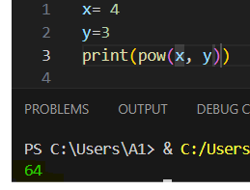

Python has also a built-in module called math, There are many functions in Python, especially in Math. To do this, you use a word called “import”, then the word “Math”.

* Ceil(): method rounds a number upwards to its nearest integer.

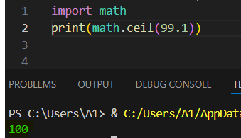

* Floor(): method rounds a number downwards to its nearest integer.

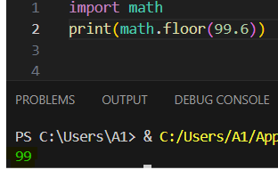

* Sqrt(): method returns the square root of a number

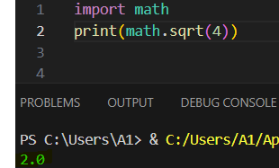

* Pi: constant, returns the value of PI

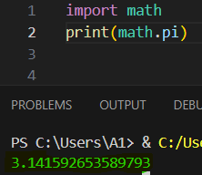

Finish the lesson!!!

Lesson5

# Project level3

This is final level: you require to create this is project: -

You are required to implement a Python program that collects the names of students and saves them in a list. When you type five people, a message with the names of the students is displayed via for loop, range.

Like:

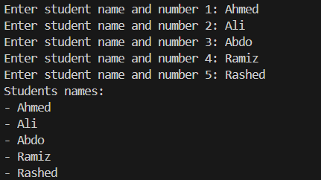

You can follow these steps:

1. Create a list for students
2. Set the for loop to repeat the entry more than once, provided that it does not exceed five times, and each time it is repeated, it adds the name to the list.
3. Print each item from the list using a for loop

Finish the level!!!…